TRAFFIC MANAGEMENT SYSTEM

* **TRAFFIC INFORMATION PLATFORM (web development):**

**DATA SOURCES**

Identify the sources for real-time traffic data. These can include APIs from government transportation agencies, GPS data, and traffic camera feeds.

MAP INTEGRATION:

Use libraries like Leaflet or Google Maps API to display traffic conditions on a map. Incorporate features like markers for incidents, traffic flow, and route recommendations.

**REAL-TIME DATA INTEGRATION:**

Develop code to fetch and display real-time traffic data on the platform. Ensure the data is updated regularly.

USER ACCOUNTS:

Implement user registration and login for a personalized experience. This can help users save their favorite routes and settings

**ROUTE RECOMMENDATIONS:**

Develop an algorithm that can analyze traffic data and recommend the best routes to users based on their preferences

**TESTING:**

Rigorously test the platform to ensure accuracy and performance. Test on various browsers and devices to ensure compatibility

CODEPEN:

https://codepen.io/your-work

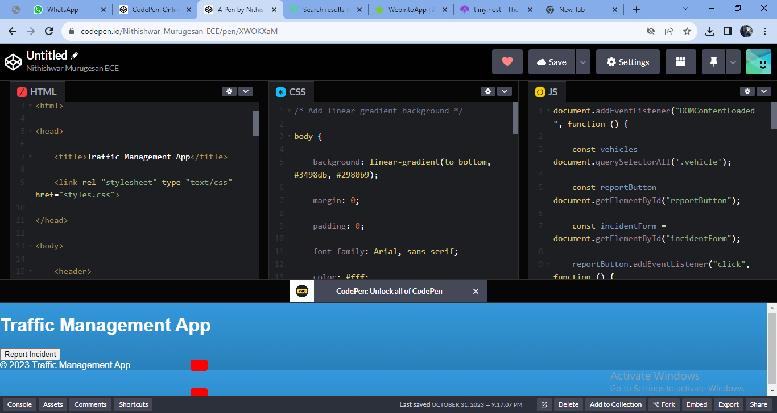

**HTML CODE:**

<!DOCTYPE html>

<html>

<head>

<title>Traffic Management App</title>

<link = ”stylesheet" type="text / cs"="styles.css">

</head>

<body>

<header>

<h1>Traffic Management App</h1>

</header>

<main>

<div id="map">

<div class="vehicle car"></div>

<div class="vehicle truck"></div>

<-- Add more vehicle elements as needed -->

</div>

<button id="report Button">Report Incident</button>

<div id="incident Form" style="display none;">

<h2>Report an Incident</h2>

<form>

<label for="incident Type">Incident Type:</label>

<select id="incident Type">

<option value="Accident">Accident</option>

<option value="Road Closure">Road Closure</option>

< -- Add more incident types -->

</select>

<label for="location">Location:</label>

<input type="text" id="location">

<button id="submit Report">Submit</button>

</form>

</div>

</main>

<footer>

&copy; 2023 Traffic Management App

</footer>

<script ="app.js"></script>

</body>

</html>

**CSS CODE:**

/* Add linear gradient background */

body {

background: linear- gradient (to bottom, #3498db, #2980b9);

margin: 0;

padding: 0;

font-family: Arial, sans-serif;

color: #fff;

}

/* Style the vehicles */

Vehicles {

width: 30px;

height: 20px;

position: absolute;

background: #f00; /* Red color for vehicles */

border-radius: 4px;

animation: move Vehicle 5s infinite linear;

}

car {

top: 100px;

left: 20px;

}

truck {

top: 150px;

left: 60px;

}

/* Add keyframes for vehicle movement animation */

@keyframes move Vehicle {

0% {

left: 0;

}

100% {

left: 100%;

}

}

**JAVA SCRIPT:**

document. Add Event Listener "DOM Content Loaded", function () {

const vehicles = document query Selector All (“vehicle');

const report Button = document get Element ("report Button");

const incident Form = document get Element ("incident Form");

report Button add Event Listener ("click", function () {

incident Form style display = "block";

});

const submit Report = document get Element ("submit Report");

submit Report add Event Listener ("click", function () {

const incident Type = document get Element ("incident Type").value;

const location = document get Element ("location").value;

// Send this data to the server or process it as needed

// You can use APIs to report incidents or perform other actions

// Example: Send data to a server using fetch ()

});

// Animation to move vehicles

Vehicles for Each (function (vehicle) {

Move Vehicle(vehicle);

});

function move Vehicle(vehicle) {

let left = -30; // Starting position off-screen

const animation Duration = 5000; // 5 seconds

const move = () => {

left += 1;

if (left > 100) {

left = -30; // Reset position when it reaches the end

}

Vehicle style. left = left + "%";

Request Animation Frame(move);

};

// Start the animation

move()

}

});

**MOBILE APPS (iOS and Android):**

**UI/UX DESIGN:**

Create a user-friendly and intuitive design for the mobile apps. Consistency with the web platform's design is crucial for a seamless experience

**DATA SYNCHRONIZATION:**

Develop code to sync real-time traffic data with the mobile apps. Use RESTful APIs or Graphical to fetch data from your web platform

**OFFLINE MODE:**

Allow users to access cached traffic information and saved routes when they're offline

**WEB PROECT:**

<https://tinny.host/>

<https://traffic> management system. Tinny. Site

CONVERT WEB INTO APP:

<https://www.webintoapp.com/app> maker

[https://www.manageengine.com/products/netfllow-traffic management.html](https://www.manageengine.com/products/netfllow-traffic%20management.html)

**ICONS:**

https://www.flaticon.com/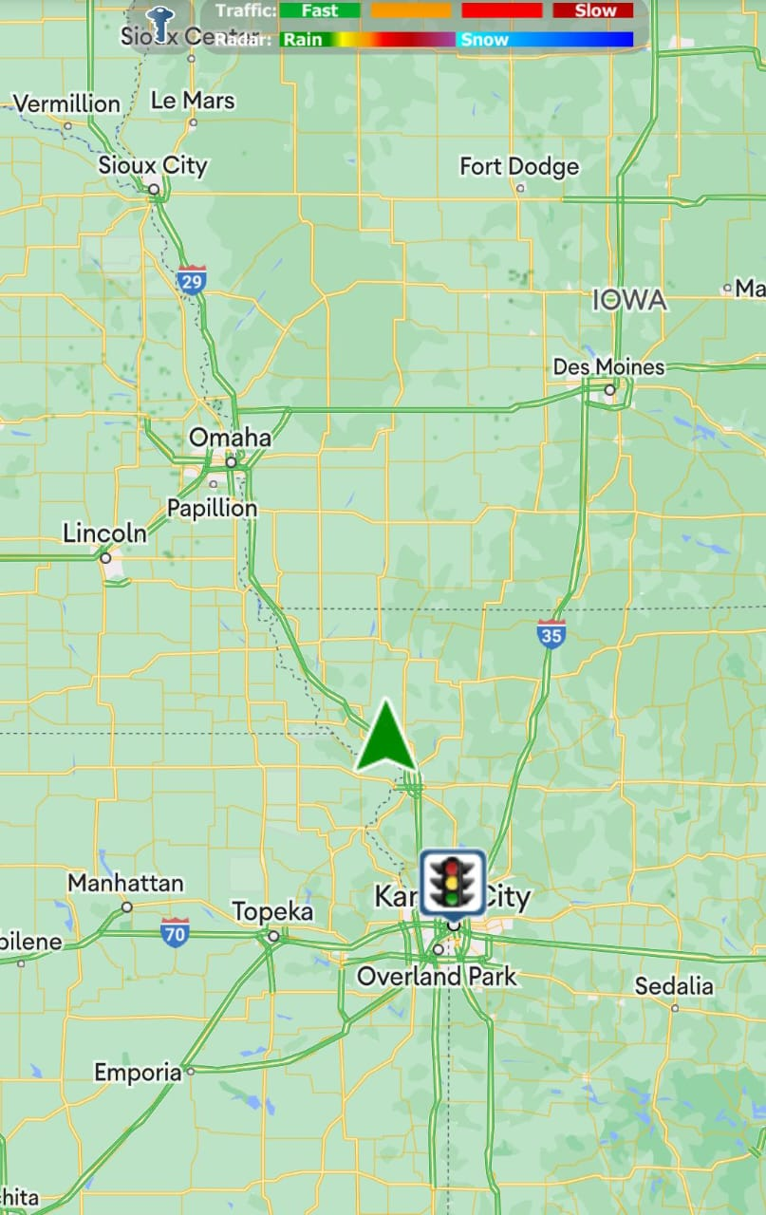

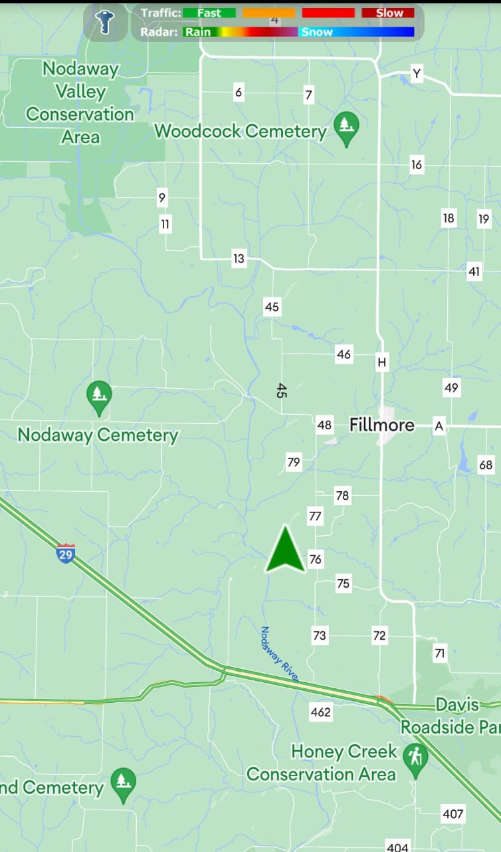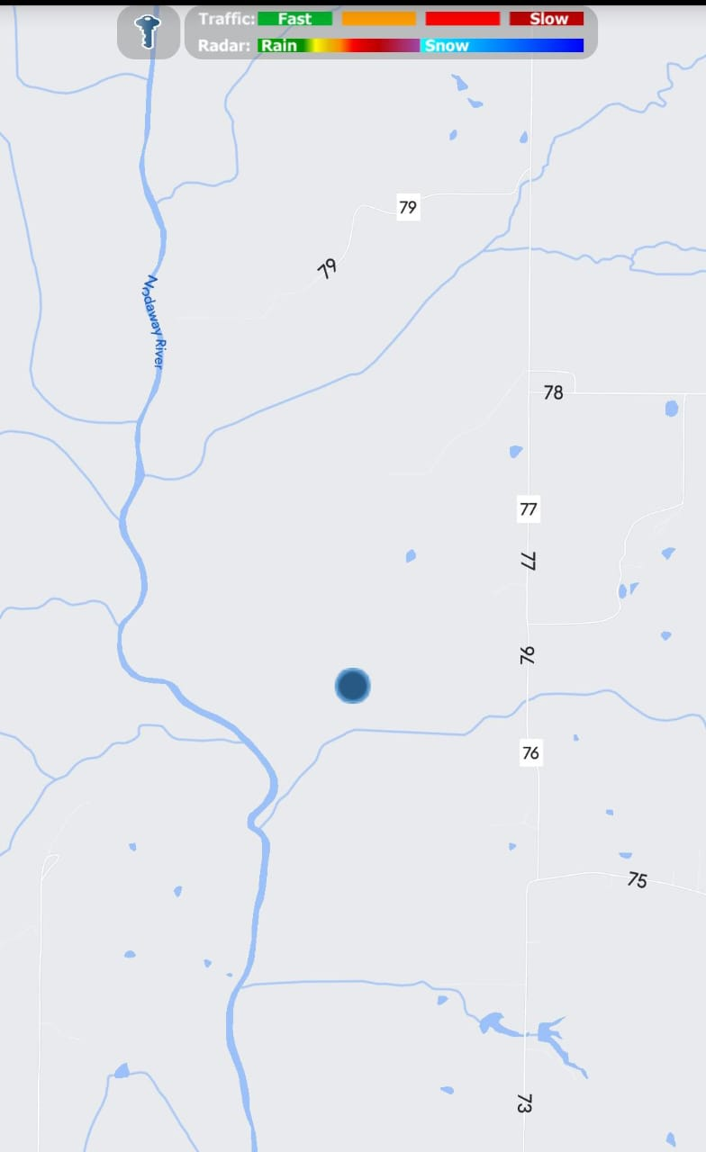

CONCLUSION:

IIn conclusion, the Traffic Management System app for Android is a vital tool in addressing the growing challenges of urban traffic congestion and road safety. Its user-friendly interface, real-time traffic updates, and route optimization features make it an indispensable tool for commuters. By promoting efficient traffic flow and reducing congestion, this app not only enhances the daily commute but also contributes to a greener and safer urban environment. It represents a significant step forward in harnessing technology to address one of the most pressing issues of modern urban life.

**APP NAME:**

Traffic management

* App- release.mode